**Hackathon Project Phases Template** for the **StudBud: AI Study Planner**

App Designed Project

# Hackathon Project Phases Template

**Project Title:**

**StudBud - AI Study Planner**

**Team Name:**

(**Craftech)**

**Team Members:**

* T. AMRUTHA
* B. SARANYA
* S. SUSHANTHI

## Phase-1: Brainstorming & Ideation

**Objective:**

The **StudBud AI Study Planner** aims to revolutionize personalized learning by integrating AI-driven study planning with craft-based education. Utilizing **BERT-based NLP models and Gemini AI**, StudBud generates dynamic study schedules tailored to students' strengths, weaknesses, and goals. This hybrid approach promotes **academic excellence and creative.

**Key Points:**

1. **Problem Statement:**

• Students struggle with **time management** and **personalized study plans**.

• Traditional study planners lack **AI-driven customization** for strengths, weaknesses, and learning styles.

• No integration of **academic learning with craft-based skills** for holistic education.

**2.Proposed Solution:**

• AI-powered **personalized study plans** based on students' subjects, weak areas.

• Uses **BERT & Gemini AI** to suggest **smart study topics** and optimize schedules.

• **Hybrid learning approach** blending academics with craft-based skill.

#### **3.Novelty & Uniqueness:**

* **First-of-its-kind AI planner** combining **education + craft learning**.
* **Handcrafted UI theme** for a visually engaging experience.
* **Real-time adaptive study recommendations** using **BERT & Gemini AI**.

**4.Expected Outcomes:**

* **Efficient & personalized learning** tailored to students' strengths.
* **Enhanced skill development** through academic + craft learning integration.
* **Higher engagement** with gamification & interactive elements.

## Phase-2: Requirement Analysis

**Objective:**

Define the technical and functional requirements for the StudBud App

**Key Points:**

1. **Technical Requirements:**

The application will be built using a combination of web technologies (HTML, CSS, JavaScript) and backend AI-powered logic.

1. Frontend (User Interface & Experience)
2. HTML: Structuring the content and layout of the application.
3. CSS: Styling elements, ensuring a handcrafted, craft-based UI with an engaging visual experience.
4. JavaScript:
   1. Implementing interactive elements (drag & drop study scheduling, gamification).
   2. Enhancing user experience with real-time updates and animations.
   3. Fetching AI-generated study plans dynamically.

**Backend (Logic & AI Integration)**

* **Python (Flask/FastAPI):** To handle API requests and serve AI-generated study plans.
* **BERT & Gemini AI:** AI models for NLP-driven study recommendations.
* **Database (Firebase/PostgreSQL):** To store user preferences, progress tracking, and generated plans.

**Deployment & Hosting**

* **Cloud Hosting:** Firebase/Heroku for easy deployment and scalability.

1. **Functional Requirements:**

The app must be able to:  
✅ Allow users to **input subjects, weak areas, and study duration** for AI-based planning.  
✅ Generate **customized study schedules** dynamically based on AI recommendations.  
✅ Provide **progress tracking** with streaks, badges, and reminders.  
✅ Offer **interactive elements** such as drag-and-drop scheduling and gamified challenges.  
✅ Enable **collaborative study sessions** and AI-powered Q&A features.  
✅ Support **responsive UI** for both desktop and mobile users.

.

1. **Constraints & Challenges:**

⚠ **AI Model Processing Speed:** Generating study plans must be fast and optimized for real-time responses.  
⚠ **User Engagement:** Ensuring students actively use the app through gamification & personalization.  
⚠ **Integration of Craft Learning:** Developing a seamless way to blend craft-based skill learning with academic planning.  
⚠ **UI Complexity:** Balancing a **handcrafted-themed UI** with modern UX principles for usability.  
⚠ **Data Security:** Protecting user data, preferences, and study progress from unauthorized access..

## Phase-3: Project Design

**Objective:**

Develop the architecture and user flow of the application.

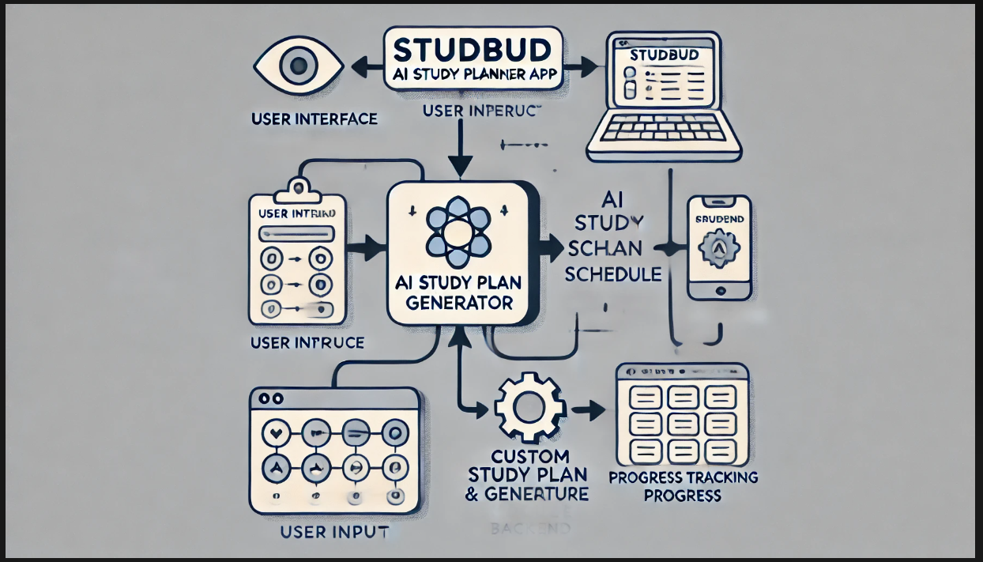

**Key Points:**

**1.System Architecture:**

1] **Frontend:** React.js/Vue.js for an interactive, responsive UI.

2] **Backend:** FastAPI/Django handling AI logic & authentication.

3] **AI Processing:** Google Gemini/OpenAI for personalized study plans.

4] **Database & Cloud:** PostgreSQL/MySQL with Firebase/AWS for storage.

**2.User Flow**:

• **Home Screen:** User enters the app and selects study goals.

• **AI Study Plan Generator:** User inputs available study time, weak subjects.

• **Dashboard:** Displays progress bars, upcoming tasks, and AI.

• **Interactive Study Planner:** Drag & drop feature for scheduling.

• **Collaboration & Group Study:** Join study groups, chat with AI tutor.

• **Gamification Features:** Streaks, badges, and progress rewards.

• **Reports & Insights:** AI-generated performance reports and study analytics.

**3.UI/UX Considerations:**

* + **Handcrafted Theme:** Inspired by **traditional crafts** (wood texture, embroidery buttons).
  + **Minimalistic & Clean UI:** Smooth navigation with a **modern yet warm feel**.
  + **Gamified Progress Tracker:** **Streaks, points, and rewards** to boost motivation.
  + **Drag & Drop Interface:** For an intuitive study plan customization.
  + **Dark & Light Mode:** To enhance usability for long study hours.
  + **Accessibility Features:** Voice commands, screen reader support for all

## Phase-4: Project Planning (Agile Methodologies)

**Objective:**

Break down development tasks for efficient completion.

**StudBud - AI Study Planner**:

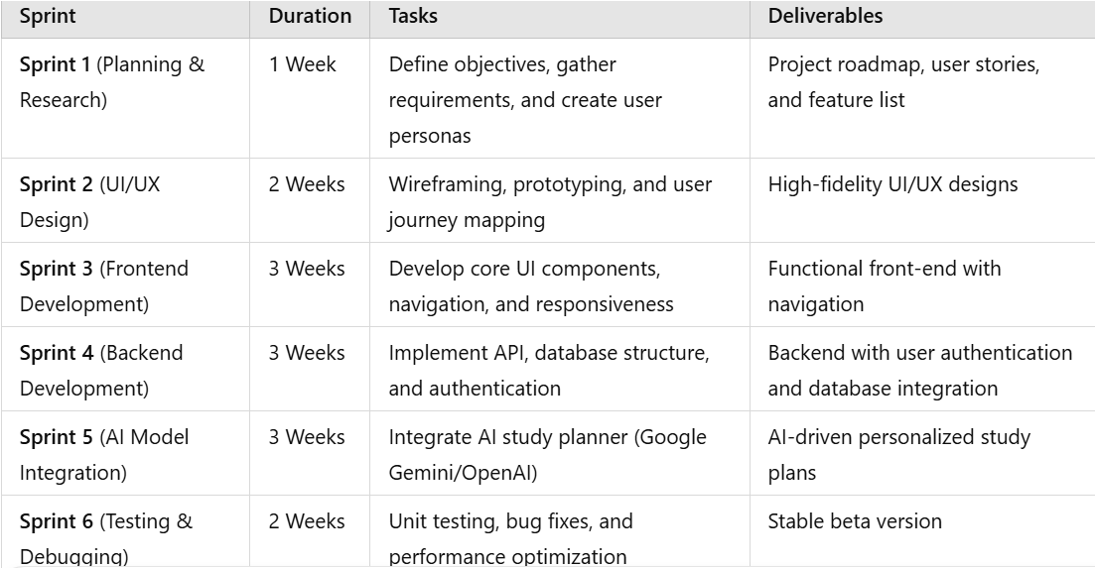

**Sprint Planning with Priorities** :

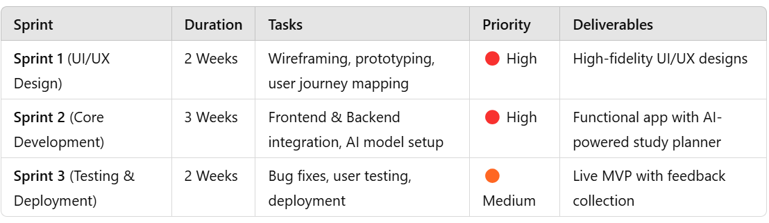

## Phase-5: Project Development

**Objective:**

Implement core features of the StudBud App.

**Key Points:**

1. **Technology Stack Used:**

* **Frontend:** HTML, CSS, JavaScript
* **Backend:** Python (Flask/Django)
* **Database:** Firebase / PostgreSQL
* **AI Integration:** Google Gemini API
* **Hosting:** AWS / Firebase Hosting

**2 . Development Process:**

• Sprint 1: UI/UX Design (Wireframing, User Flow)

• Sprint 2: Core Development (Frontend, Backend, AI Integration)

• Sprint 3: Testing & Deployment (Bug Fixes, User Testing, Final Launch)

**3 .Challenges & Fixes:**

• AI Response Accuracy: Tuned AI model for better personalization

• Data Security: Implemented encryption & access control

• Performance Optimization: Optimized database queries & caching

## Phase-6: Functional & Performance Testing

**Objective:**

Ensure that the StudBud App works as expected.

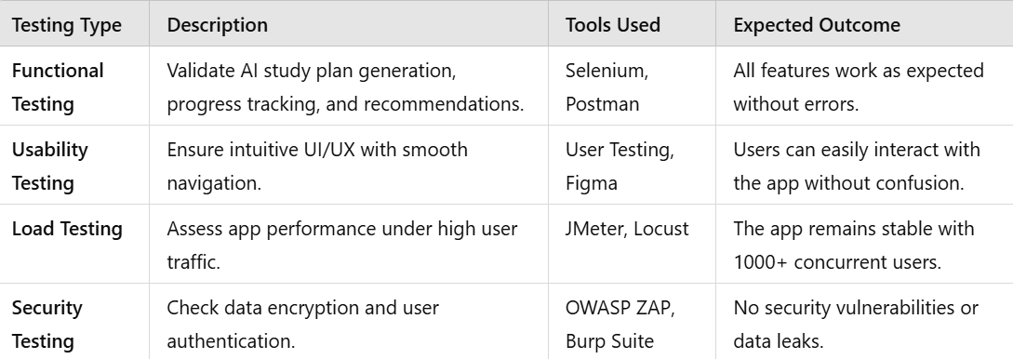

## Final Submission

1. **Project Report Based on the templates**
2. **Demo Video (3-5 Minutes)**
3. **GitHub/Code Repository Link**
4. **Presentation**